Lab 7 Trends

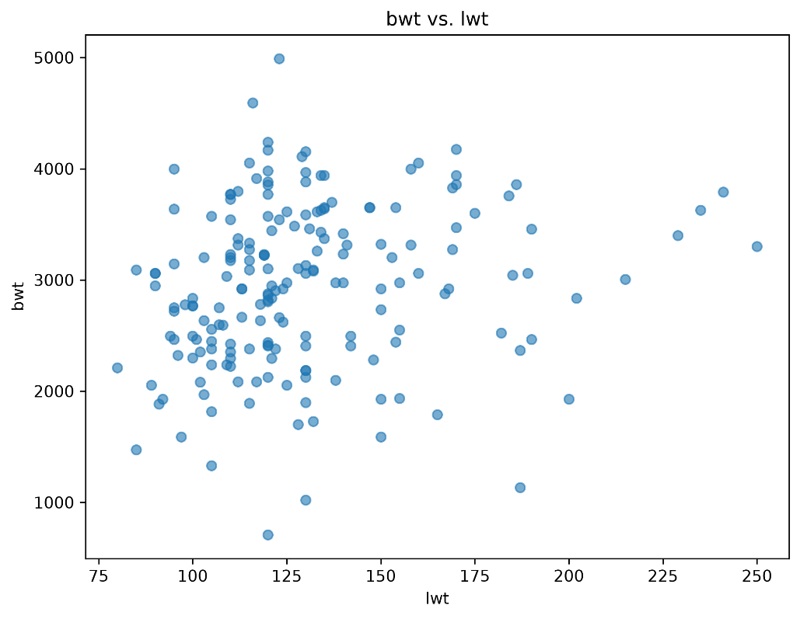
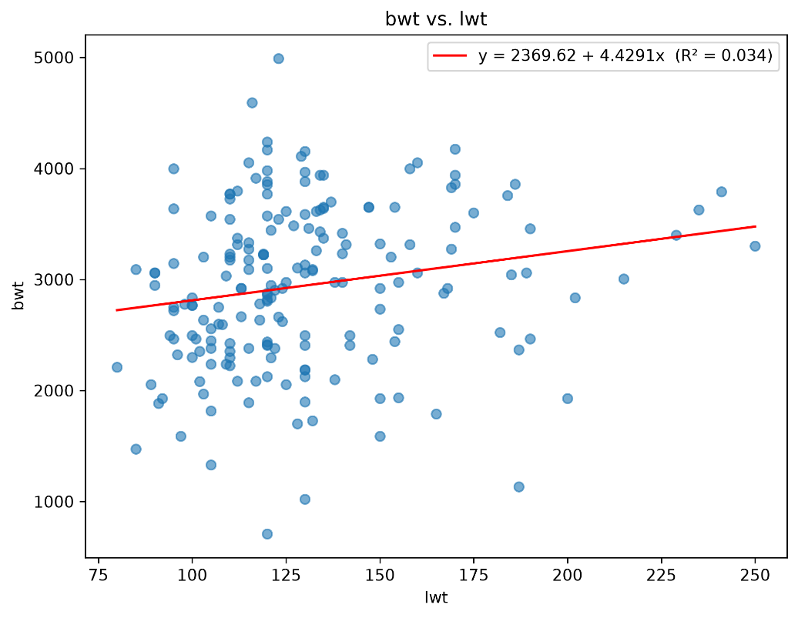
Independent variable: lwt (mother's weight in pounds)
Dependent variable: bwt (birthweight in grams)
β0 (intercept): 2369.6235
β1 (slope): 4.4291
R²: 0.0345
This scatterplot and regression line show a weak positive relationship between mother's weight in pounds and birthweight in grams, with a projected increase of about 4.43 grams in birthweight for every 1 pound increase in mother's weight.
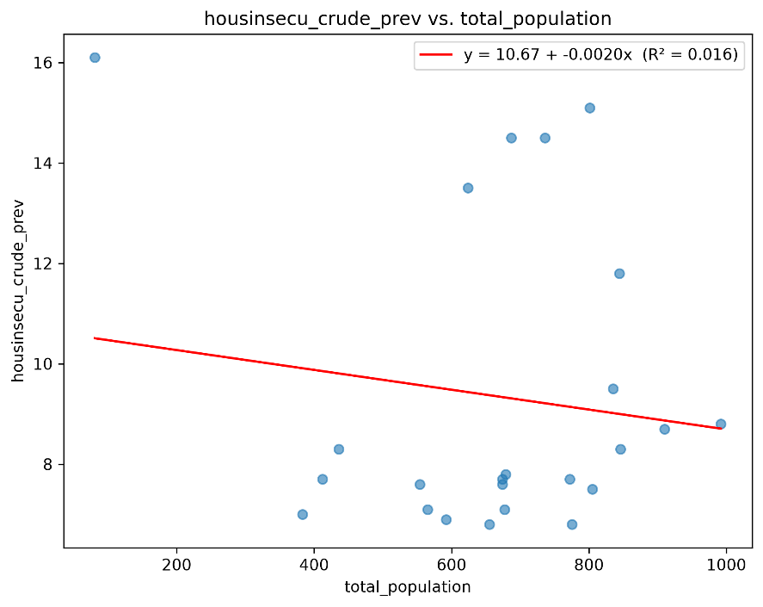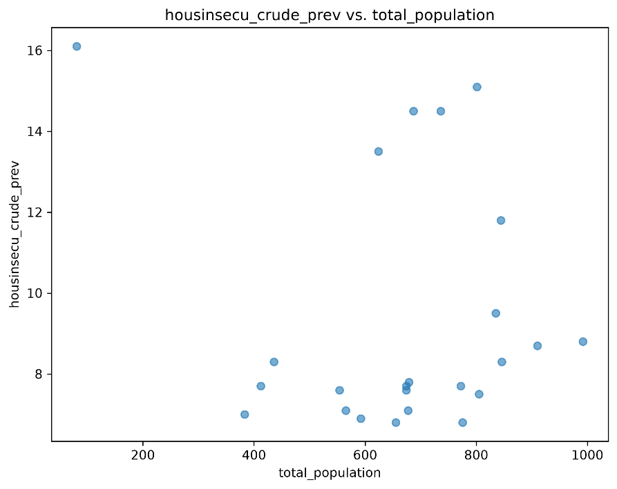

Independent variable: total_population (county total population)
Dependent variable: housinsecu_crude_prev (crude prevalence of housing insecurity)
β0 (intercept): 10.6677
β1 (slope): -0.0020
R²: 0.0164
This scatterplot and regression line show a very weak negative relationship between a county's total population and crude prevalence of housing insecurity, with a projected decrease of about 0.002 percentage points for every 1 person increase in population (about 2 points per 1,000 people).
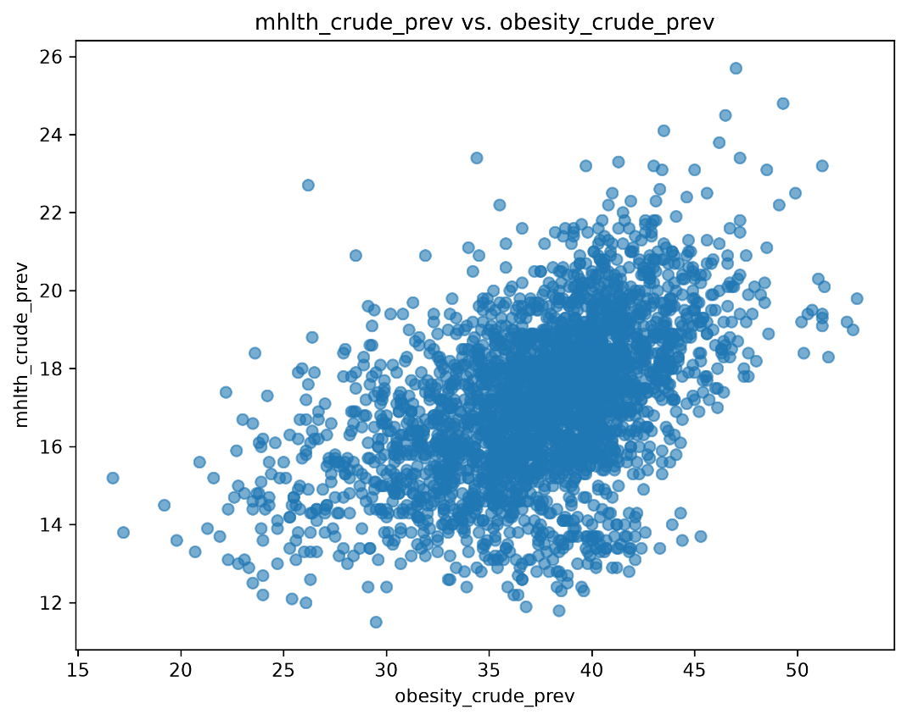
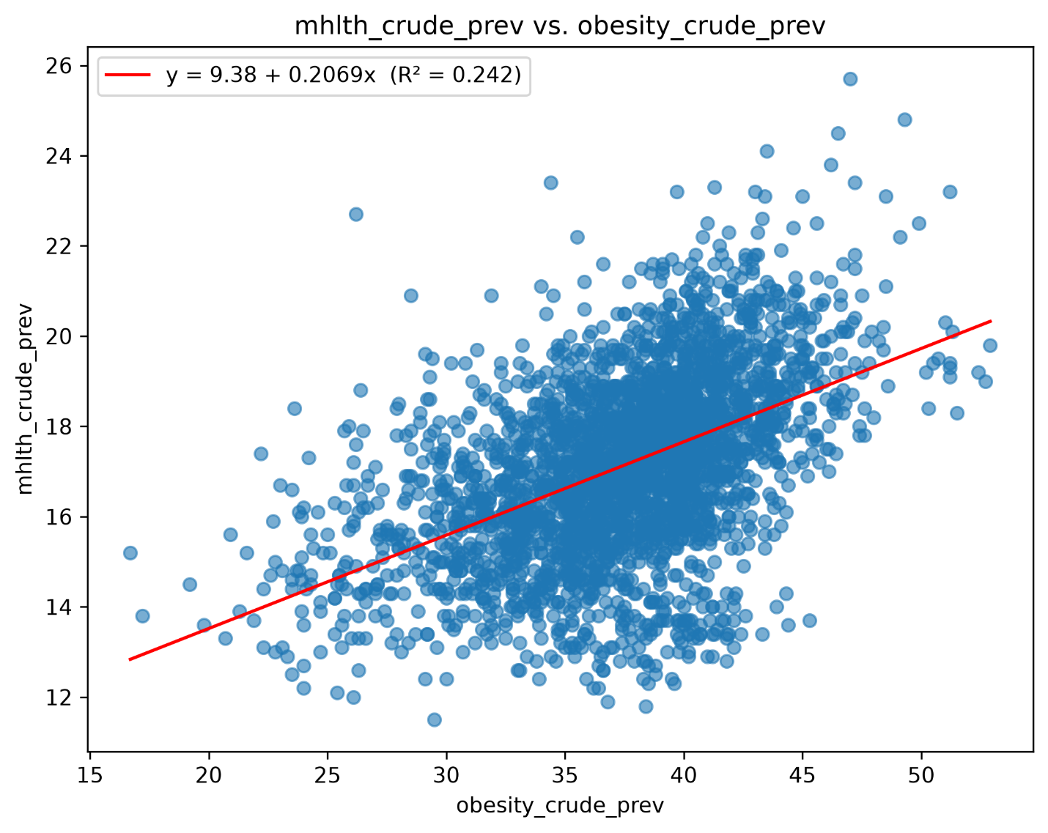
Independent variable: obesity_crude_prev (crude prevalence of obesity)
Dependent variable: mhlth_crude_prev (crude prevalence of mental health disorders)
β0 (intercept): 9.3830
β1 (slope): 0.2069
R²: 0.2418
This scatterplot and regression line show a weak-to-moderate positive relationship between crude prevalence of obesity and crude prevalence of mental health disorders, with a projected increase of about 0.21 percentage points in mental health prevalence for every 1 percentage point increase in obesity prevalence.

